**Module 7) jQuery Basic, Effects & Advanced**

**QUESTION : 1) What is jQuery?**

**ANSWER :**

jQuery is a lightweight, "write less, do more", JavaScript library. The purpose of jQuery is to make it much easier to use JavaScript on your website jQuery takes a lot of common tasks that require many lines of JavaScript code to accomplish, and wraps them into methods that you can call with a single line of code.

Initially released in 2006, jQuery gained widespread adoption due to its concise syntax and ability to handle a wide range of tasks across different browsers. It provides functions that allow developers to perform common tasks with less code compared to raw JavaScript.

**Syntax :**

jQuery syntax consists of selecting HTML elements and then performing some of action on them . The following syntax is used: $() : A leading function used to access jQuery. selector : Uses CSS selector syntax for selecting HTML elements.

**Example :**

In jQuery, the class and ID selectors are like those in CSS. Here's an example of a jQuery method that selects all paragraph elements, and adds a class of "selected" to them:<p> this is a paragraph selected by a jQuery method

**QUESTION :2) How to Apply CSS Using JQuery, How to Add Class and Remove Class in Jquery, JQuery Animation?**

**ANSWER :**

**Applying CSS Using jQuery:**

To apply CSS using jQuery, you can use the **.css()** method. Here's an example:

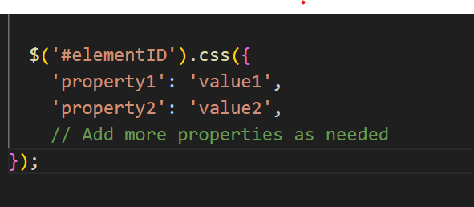

Replace **#elementID** with the ID of the HTML element you want to modify, and adjust the properties and values accordingly.

### Adding and Removing Classes Using jQuery:

jQuery makes it easy to add or remove classes from HTML elements using the **.addClass()** and **.removeClass()** methods:

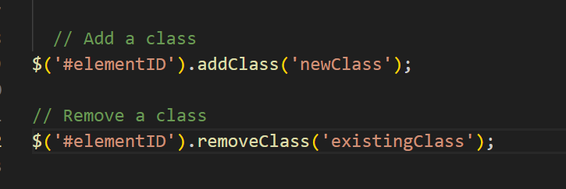

Replace **#elementID** with the ID of your HTML element, and modify the class names as needed.

### jQuery Animation:

jQuery simplifies creating animations on HTML elements. You can use methods like **.animate()** to animate changes in CSS properties. For instance, animating the width of an element:

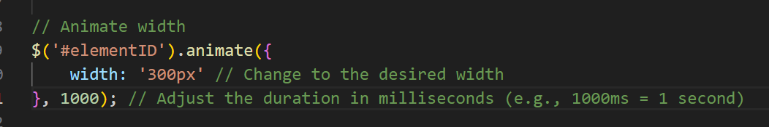

Replace **#elementID** with the ID of the HTML element you want to animate. Adjust the CSS properties you want to animate and their target values.

Additionally, jQuery provides other methods for animations, such as **.slideDown()**, **.slideUp()**, and **.fadeTo()**, among others, to create sliding, fading, or custom animations.

Remember, as modern web standards evolve, CSS transitions and animations, as well as native JavaScript methods like **classList.add()**, **classList.remove()**, and CSS properties like **element.style.property**, have become more robust alternatives to achieve similar effects without relying solely on jQuery. Depending on your project's needs, you might consider these native options or other modern libraries/frameworks for animations and DOM manipulation.

**QUESTION : 3) How to create slider with animation?**

**ANSWER :**

Step 1: Come up with a strategy for the slider.

Step 2: Update the background image in each slide.

Step 3: Update the text layers in each slide.

Step 4: Edit the button text and design in each slide.

Step 5: Edit the slider navigation.

Creating a slider with animation typically involves using HTML, CSS, and JavaScript. Here's a basic example to create a simple slider with animation using these technologies:

**HTML Structure :**

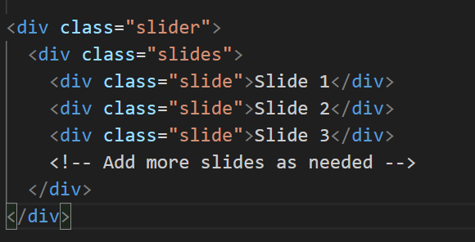

**CSS Styling :**

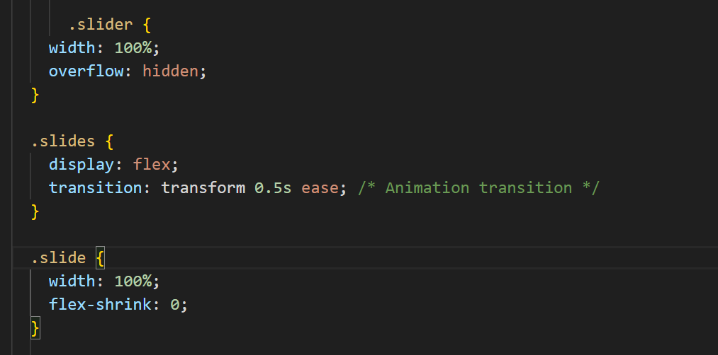

**JavaScript for slider functionality :**

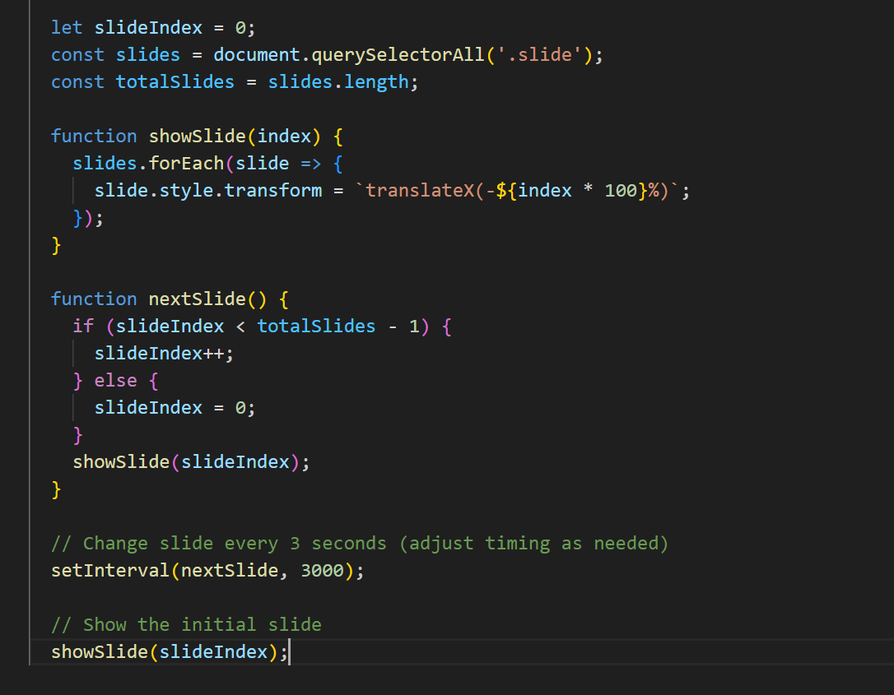

This code sets up a basic slider that automatically transitions between slides every 3 seconds. You can customize the HTML, CSS, and JavaScript according to your specific design and functionality requirements. Additionally, you might want to incorporate additional features like navigation buttons or pagination depending on your project's needs.